**Online Canteen ordering system for unilever:**

**Stake Holders:**

|  |  |
| --- | --- |
| **Actor** | **What they can do on the software created** |
| Employee/customer | * BY clicking on add button employee can be able to order more than one item at a time. * This can minimize the ordering time for multiple items/dishes. |
| Canteen Manager | * HE can be able to view number of orders and type of dishes ordered by the employee that to be cooked. * Also able to track number of orders per day. * Able to track type of dishes which are ordered more by the employees. |
| Delivery Boy | * HE should be able to deliver the dishes to the respected employee desk on time. * Once the items are delivered, he should be able to close the order. |
| Payroll System | * It should be able to track number of dishes and type of dishes that is ordered according to pricing. * Automatically deduct total ordering amount for a month from the customers. |
| Management | * Easy access to the software. * Should be able to deliver the order on time. * Must reduce the food wastage. * Able to cook on customers’ choice. |
| chef | * Prepare and process the food. |

**Problem Definition and Solution:**

* Only 2 canteens are available consisting 150 seats each for 1500 employees. So there is an insufficient canteen space for the employees.
* Huge food wastage in a day and high maintenance cost.
* Employees need at least 30mins to stand in a queue to collect their food and get a table to eat.
* Sometimes employees didn’t get their choice of food due to running out of dishes.

**Advantages and Objectives:**

**Advantages of the Canteen Ordering System:**

* By implementing this online canteen system the food wastage is reduced.
* The maintenance cost and number of workers can be reduced which leads to high profit to the management.
* Customer feedback leads to quality improvement.
* Customer can order the item what they prefer.
* It helps employees to reduce the waiting time and able to focus more on their daily work.

**Objectives:**

* Employees should able to get the food of their choice and also have feasibility to add more items to their cart.
* Order delivery to the employees work station on time.
* User interface and functionality of the system should be user friendly.
* System should be able to update the menu daily and able to track most popular dish, total monthly earnings, sales of each day etc.
* Payroll system able to find total pricing of the dishes ordered in a month and automatically deducts money from the employee salary.
* Should have feedback option to give ratings and reviews by the employee.
* Delivery boy should able to close the order once it is delivered/

**Existing System:**

* In present system employees has to rush to the canteen and stand in a queue to get their food and also has to wait sometime until the tables are vacant.
* It is a time consuming and complex system.
* There is a hue food wastage and high maintenance cost.
* There is no online delivery system for the canteen and no feedback system for the customers/employee.

**Proposed System:**

* The proposed system is to implement the online food delivery system to the employee/customer.
* The system should be user friendly interface and should be able to understand the terminology at ease to every employee/customer.
* There should be an automated payroll system and also feedback option.
* The food menu has to update daily and lists all available dishes for the day.
* Employee should have the feasibility to change their order and has to confirm before 11am.
* Delivery of the order to the employee work station.

**Business Requirements:**

**Business Objective 1:**

* Reduce canteen food wastage by a minimum of 30% within 6 months following first release.
* Value of food thrown away each month should examine by the canteen inventory.
* Previously 25% wasted, plan for Less than 15%.

**Business Objective 2:**

* Reduce canteen operating costs by 15% within 12 months, following initial release.

**Business Objective 3:**

* Increase average effective work time by 30 minutes per employee per day, within 3 months.

**Business Objective 4:**

* By making the ordering process automated and by delivering the food to the user's workstation, the canteen will be able to operate with lesser manpower.

**Scope using Use case Diagram:**

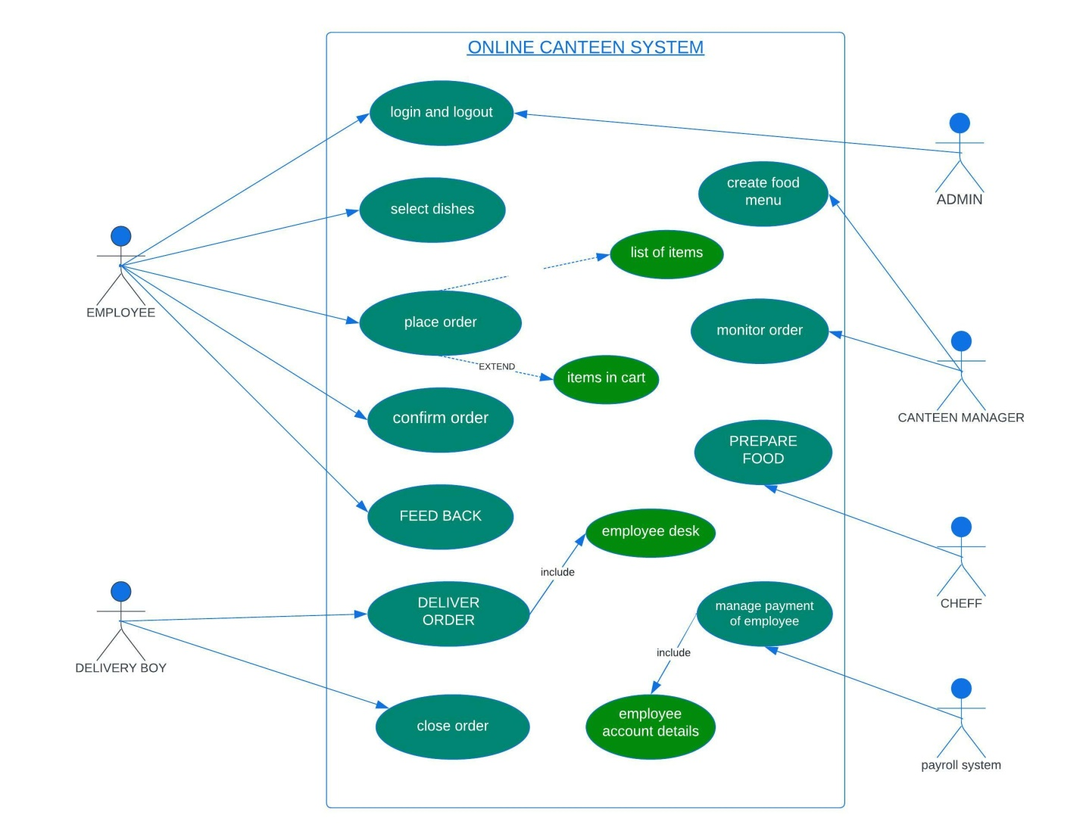

**IN SCOPE FEATURES:**

|  |  |
| --- | --- |
| **In Scope Features** | **How It Could Be Used** |
| Web Application | There Should Be A Web Application To Order Food Online |
| Menu Bar | List Of All Items And Updated Menu Daily |
| Add Cart | System Should Have The Feasibility To Create And Delete Their Menu |
| Place Order Option | After Selection Of The Items, Place The Order |
| Confirm Order | Confirm The Order That is Placed |
| Search Bar | To Search Items/Dishes |
| Payroll System | Automatically Deducts The Amount From Employee Salary |
| Feedback | To Give Ratings Or Reviews By The Customers/Employee |

**Out of scope features:**

|  |  |
| --- | --- |
| **Out of scope functions** | **How it could be used** |
| Item tracking | Ordered cannot be tracked by the customer |
| Item cancellation | Order cannot be cancelled once it is confirmed |
| Payment gateway | Amount automatically deduct from the employee salary |
| Account creation | No need to create new account |
| Refund policy | There is no money back system |
| Marketing | No Public Marketing, Since It Is Internal Organization |
| Order cannot place after 11am | Order must placed before 11am |

**Current state flowchart:**

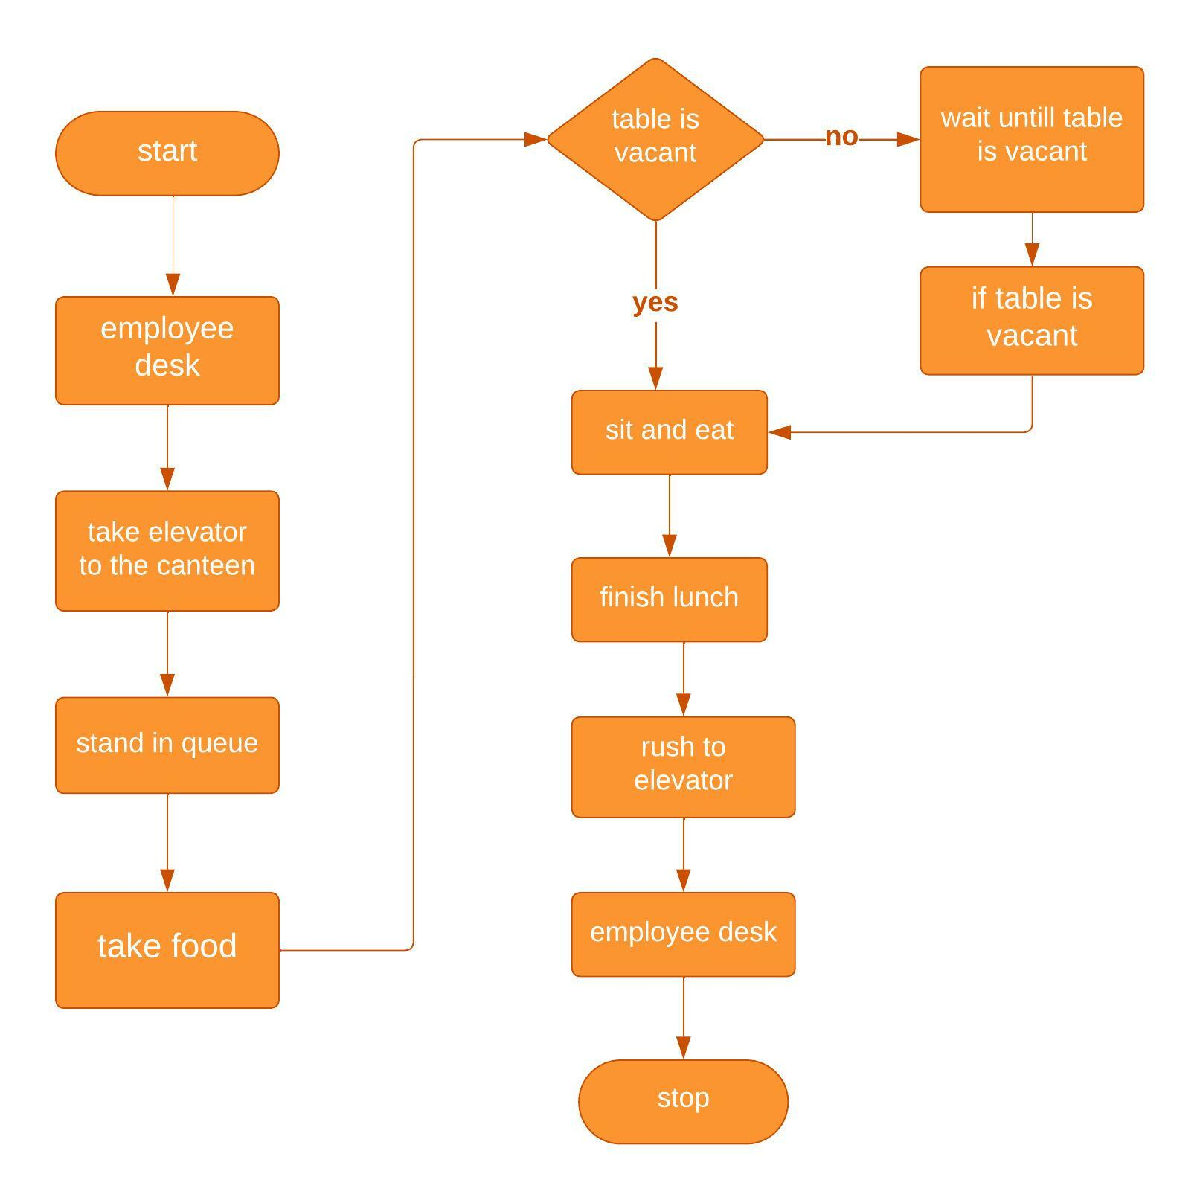

**Future state flowchart:**

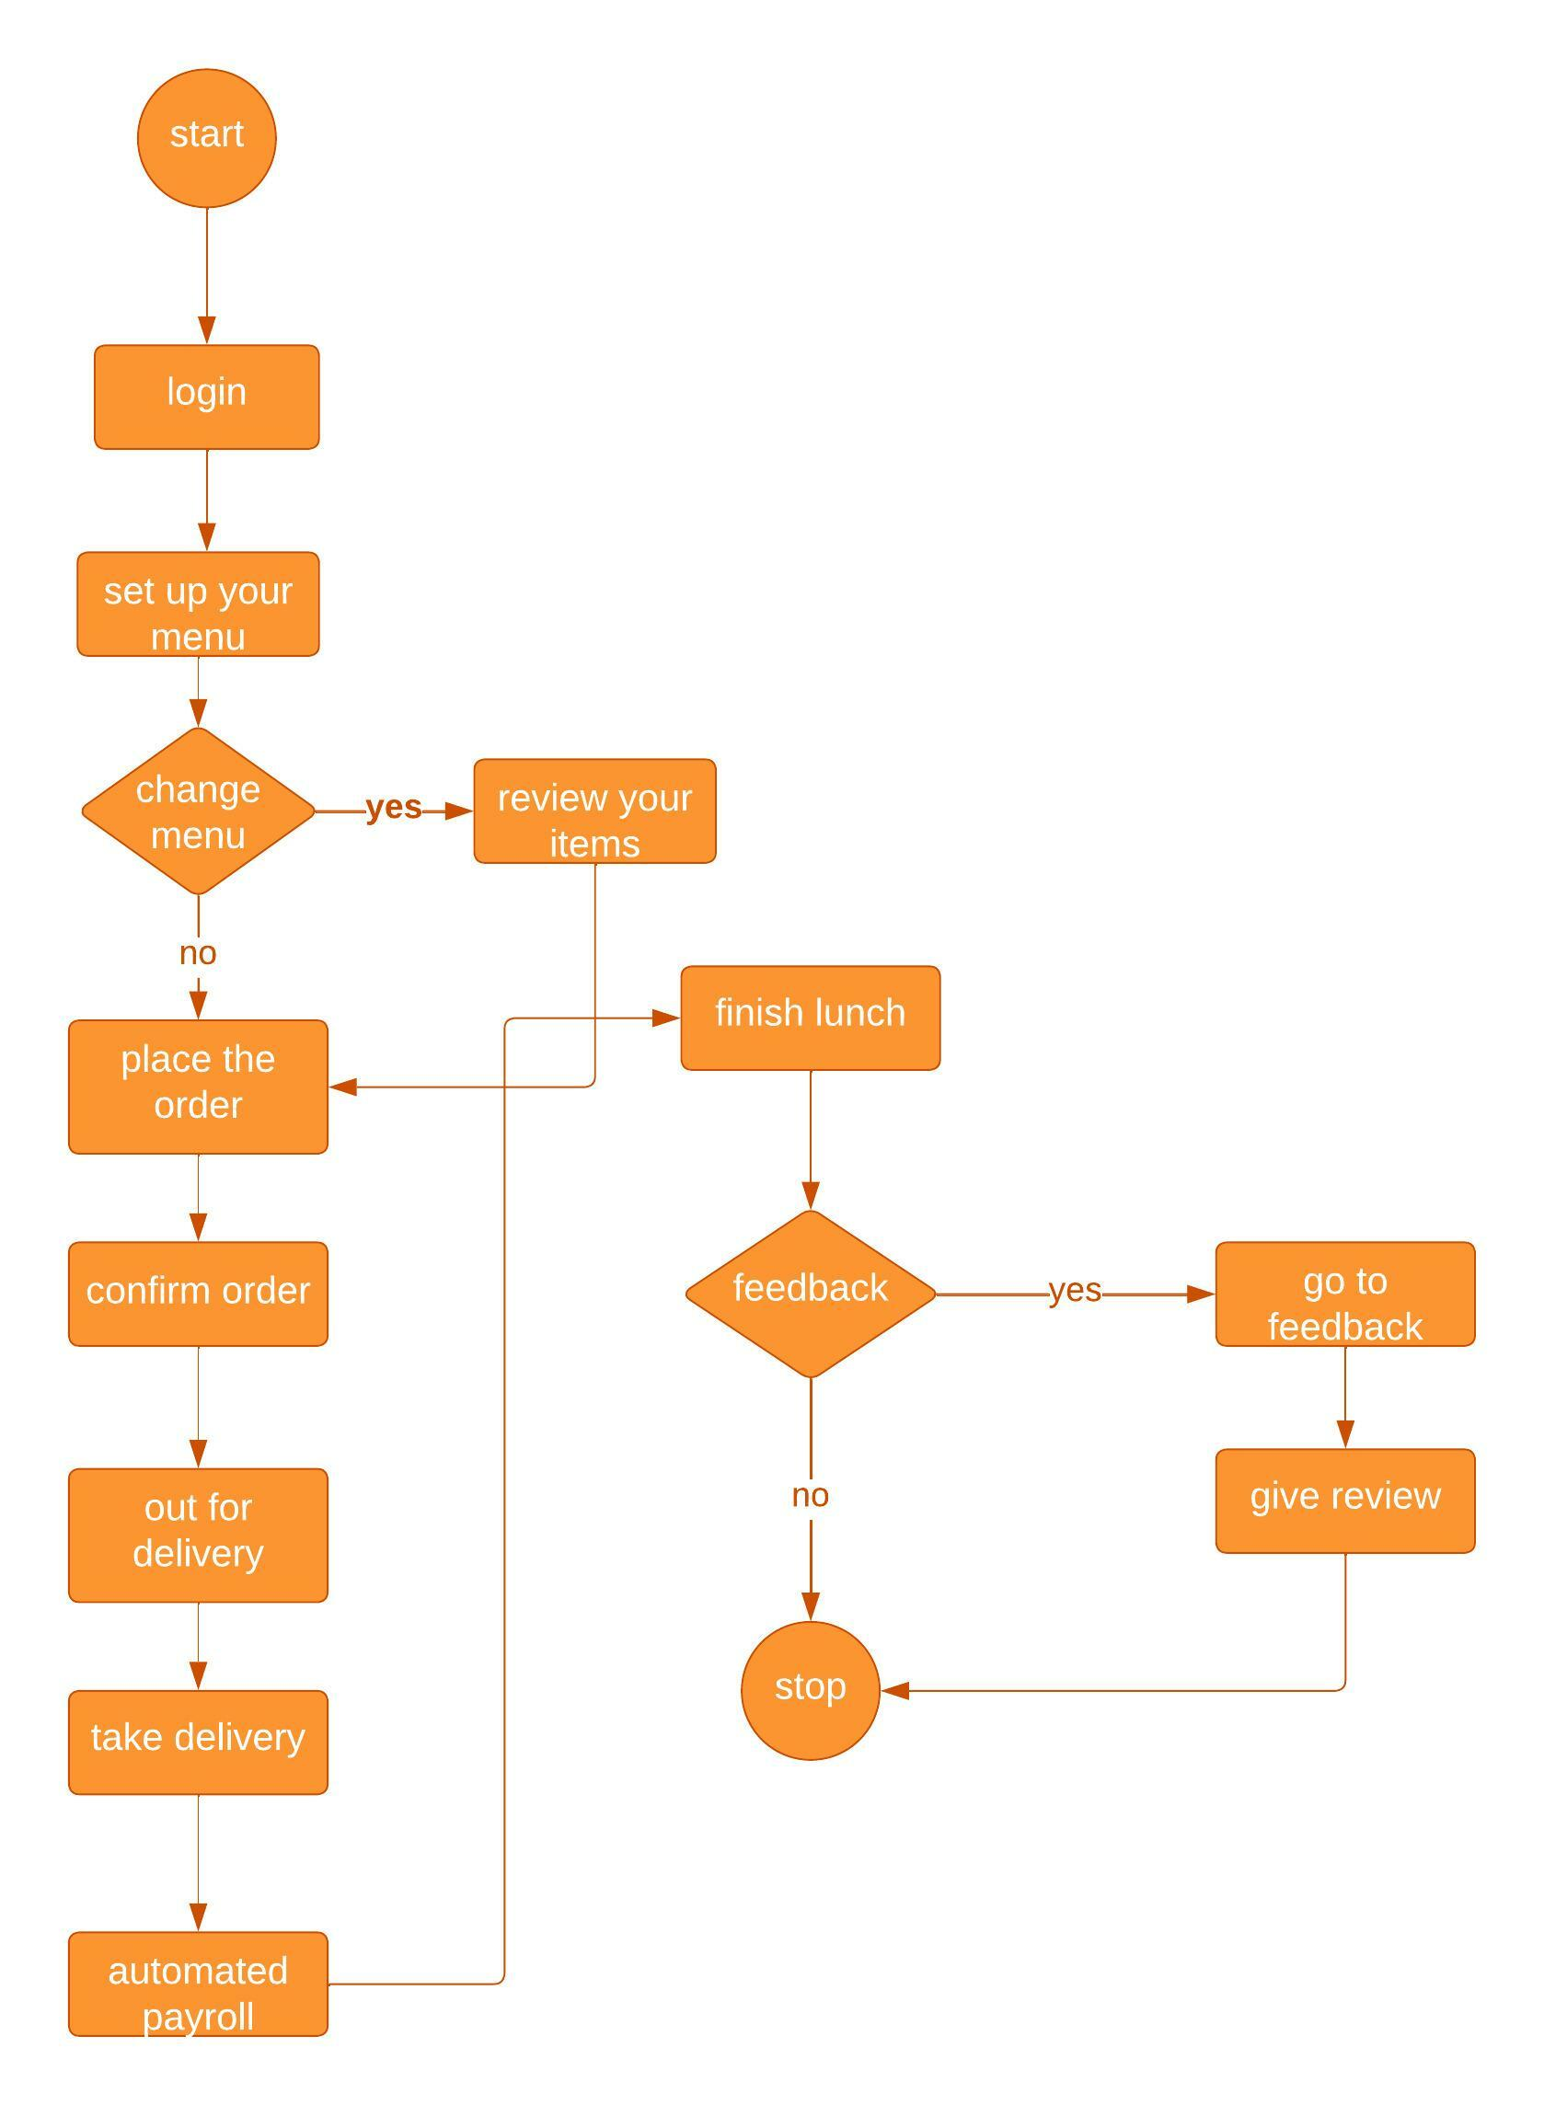

**ER Diagram:**

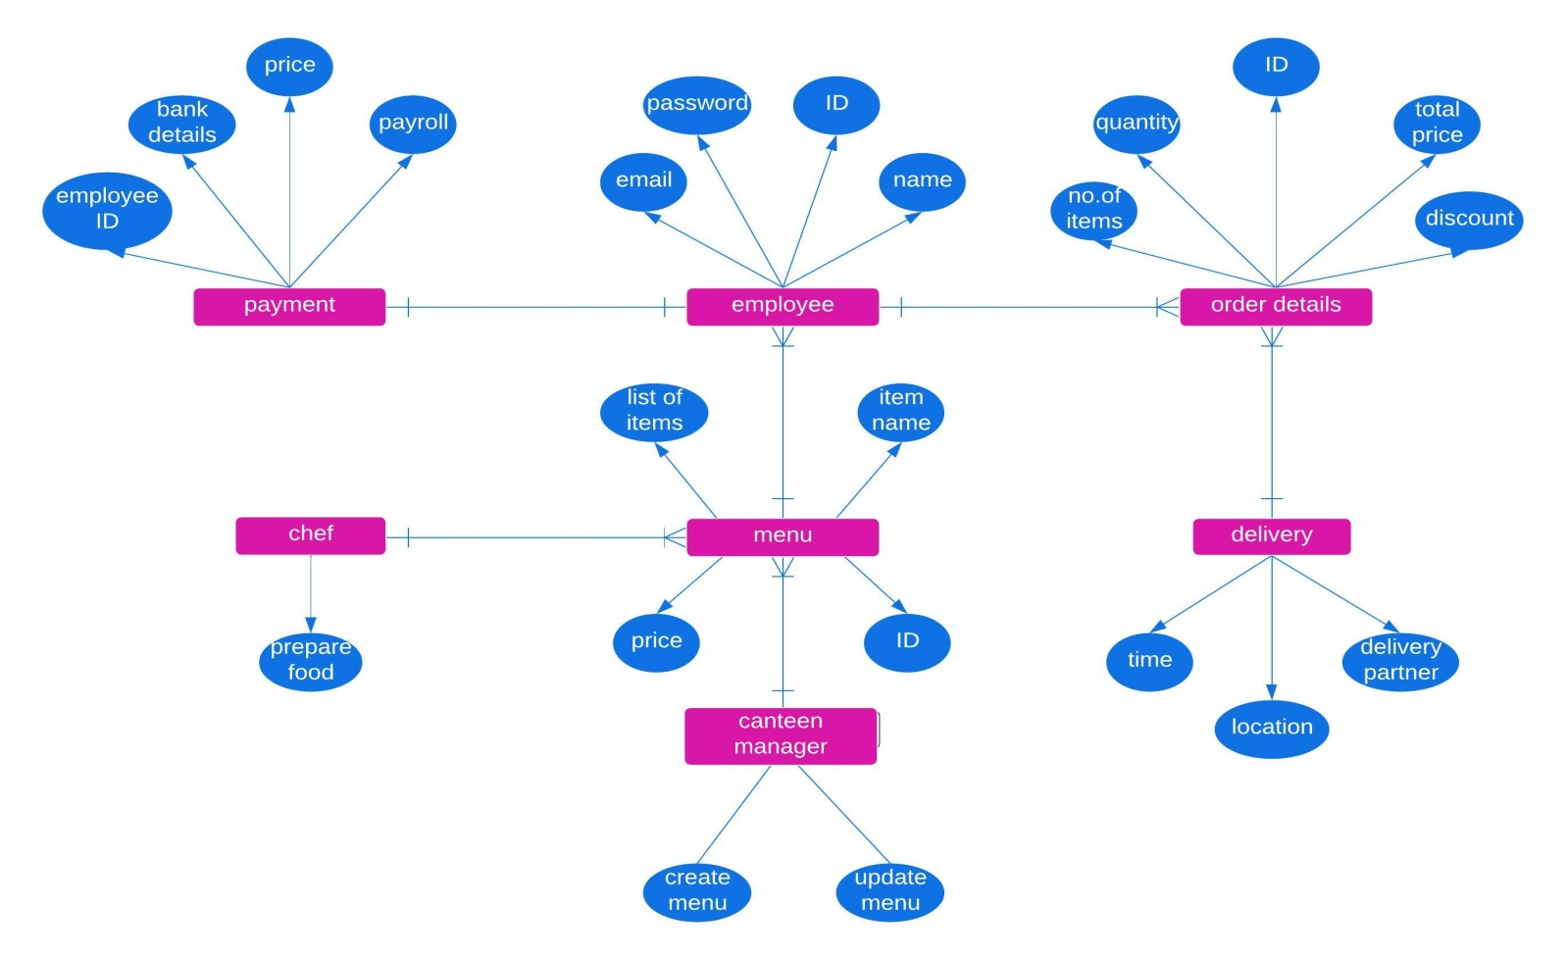

**Functional Requirements:**

1. Employee can able to access web application
2. Menu creation
3. Menu updating
4. Order selection
5. Order confirmation
6. View and monitor orders by the manager
7. Place the order before 11am
8. Feedback system
9. Automatic payment system
10. Once order is delivered, delivery boy should able to close the order
11. Management report generation:
    * Most popular dish
    * Number of employees using the system
    * Sales of the day
    * Total monthly earnings
    * Order forecasting

**Non Functional Requirements:**

1. Ordering system is requires supporting a volume of 1500 employees.
2. Web page is light and should render fast.
3. The screens are self explanatory and user friendly.
4. The data fields on the screen is easy to understand by every employee/user
5. Automated payroll system should be able to show total calculation of whole items/dishes in a month to the employee.

**Activity Diagram:**

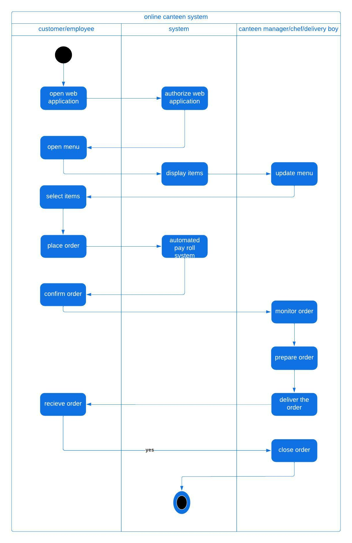

**WIRE FRAMING:**

